SQL Assignment 3

1. write a SQL query to find Employees who have the biggest salary in their Department

Query :

select e.emp_name,d.dept_name,e.salary as 'Highest Salary' from employee e left join department d on d.dept_id=e.dept_id,(select max(salary) as sal, dept_id from employee group by 2) as sq where sq.sal=e.salary and e.dept_id=sq.dept_id;

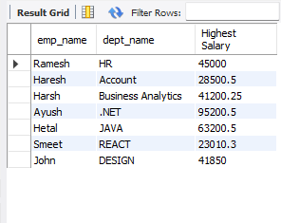

2. write a SQL query to find Departments that have less than 3 people in it.

Query :

select d.dept_name,count(emp_id) as 'No Of Employee' from employee as e right join department as d on d.dept_id=e.dept_id group by d.dept_name having count(emp_id)<3;

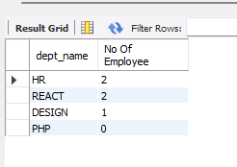

3. write a SQL query to find All Department along with the number of people there

Query :

select d.dept_name as 'Department',count(emp_id) as 'No Of employee' from employee as e right join department as d on d.dept_id=e.dept_id group by 1;

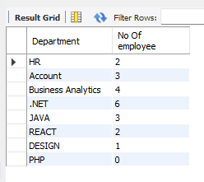

4. write a SQL query to find All Department along with the total salary there

Query :

select d.dept_name as 'Department',case when sum(e.salary) is null then '0' else sum(e.salary) End as'Total Salary' from employee as e right join department as d on d.dept_id=e.dept_id group by 1;

